SuperNanny October 2019 (SuperNanny V2)  
Documentation

Electronic: Simon, Anna; Computer science: Ismail, Ibish

Project goal:  
We had to make a working monitoring system, that could be produced cheap and by large numbers. It should monitor the air quality, CO2 content, temperature and the humidity.

Starting position:  
There was already a part of the monitoring hardware available. We had to get those components to work properly and make a hardware that include everything. That we have just one gadget at the end. So, it would be quite practical, you just have to plug in one devise, and it’s done. You would be able to look at all the data’s in a cloud.

Hardware:

We had to make some chances in the Wifi-connection. In the beginning there was only a connection from the Arduino to the cloud and it should actually by a communication from the Arduino to the Pi and afterword’s to the cloud.

There was also a problem in the Wifi-connection it wasn’t working as it should have. They had to be done some changes in the program that it was able to work.

The air quality and CO2 content sensor were drifting after some time in use. We let the sensor reset every 20min to prevent it from drifting but there was the problem that the sensor needs 20min to warm up to give useable data. We have to find the problem. The problem could be produced by many different factors. We ordered new sensors to be sure that the sensors aren’t damaged from ESD or other sings. And we made PCBs to be sure that the wrong data is not produced from the scratchboard. You can’t order 2 PCBs, no we had to order 45 PCBs, and they will arrive on the second last day. And the ordered sensors we can’t really test because we don’t have any ESD protection. We thought that Nelson would have something, but he doesn’t, so we had to order them to.   
The ESD protection arrived and the PCBs to, so we could make the power masurement

The power management hardware and software were working. There was only the problem that the wrong data was showed in the Grapf.

There was no scheme that included everything, there were not even subschemas of everything. So, we design one that included everything to in order to provide clarity.

Other problems:  
We had, in the beginning’s, problems with the communication between our team and the project owner. He never really gave as requirements of the project. And he often changed his mind about things, as if he doesn’t really know by himself what he wants. We discussed this with him to make a change that sings work the right way as they should, but he explained that he don’t want to have a final project as it was said, no he wants as to learn how it is to work in a start-up.  
There was also a problem with the equipment, we hadn’t really had any electronic equipment to make the electronic stuff, and if they had something it took always a long time to get them.

Product:  
Two different products: Power measurements and monitoring system.  
The Power measurement is working with no problem on the scratchboard, so we made a PCB that would fit in a Raspberry Pi case. It is working perfectly fine.  
An environment monitoring system where you can receive the configuration from the cloud and monitor CO2, TVOC, Temperature and Humidity. Everything works but the CO2 Sensor is drifting after several hours. And because of this we didn’t produced this PCB, we still have the scheme and a finished layout.

Stocklist:  
In the stocklist are all the components listed.

Code:  
Writhing_Database is the program to upload on the Arduinos.

Scheme:

Power measurement:  
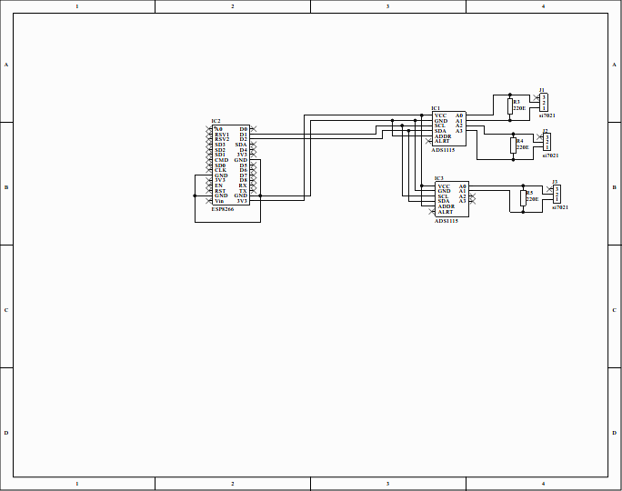

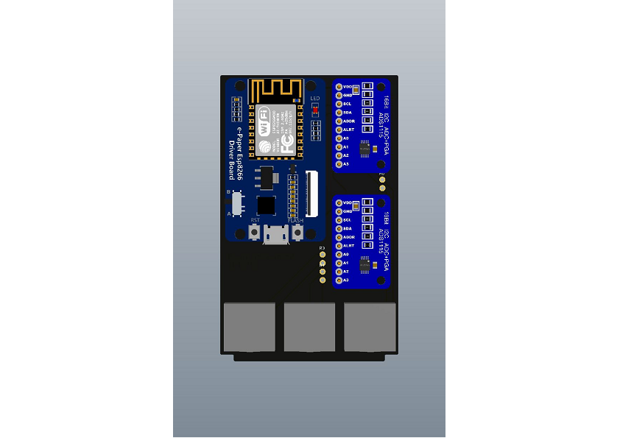

Environment monitoring  
